GIT AND GITHUB -CHALLENGES

1.Resolve Merge Conflicts.
Create a merge conflict intentionally (two users editing the same line).
Resolve the conflict and push the changes.
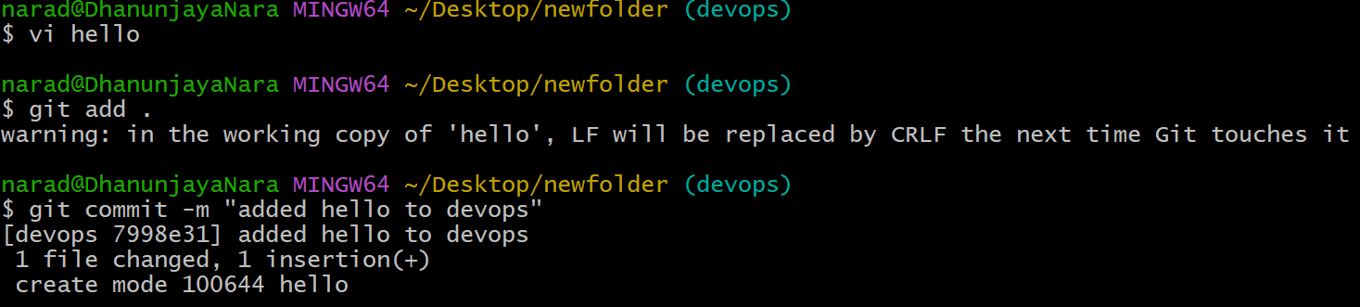
Here I created a file named hello in devops branch first. And I added that to tracking area and also committed that.
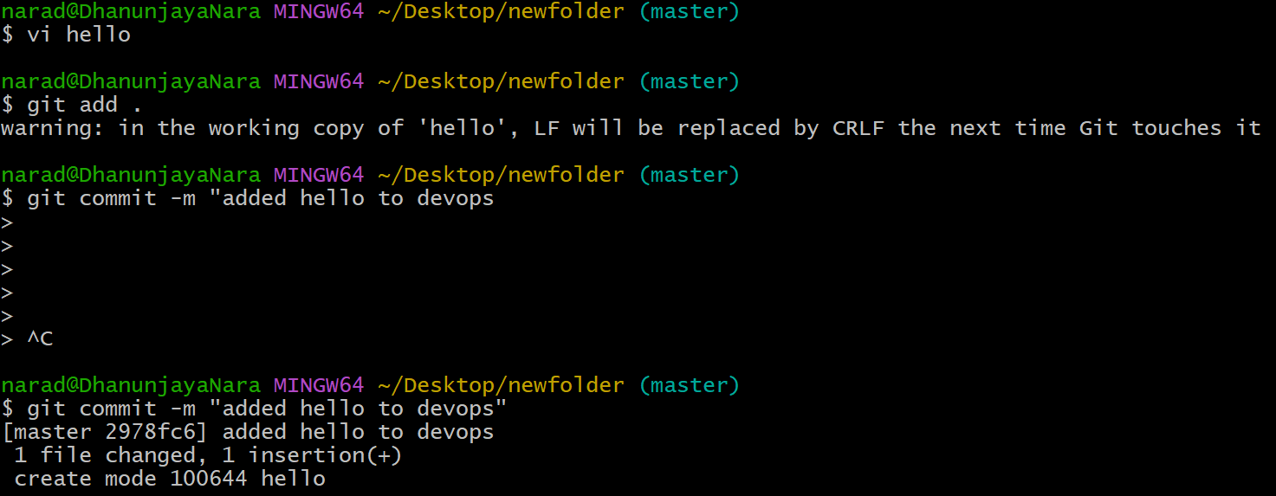
Here I create one more file named hello in master branch as well. And added that to tracking area as well as committed that.
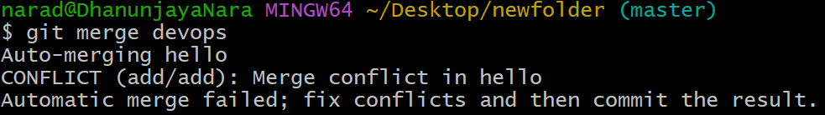
Here I merged devops branch with master and conflict happened since both filenames are same.
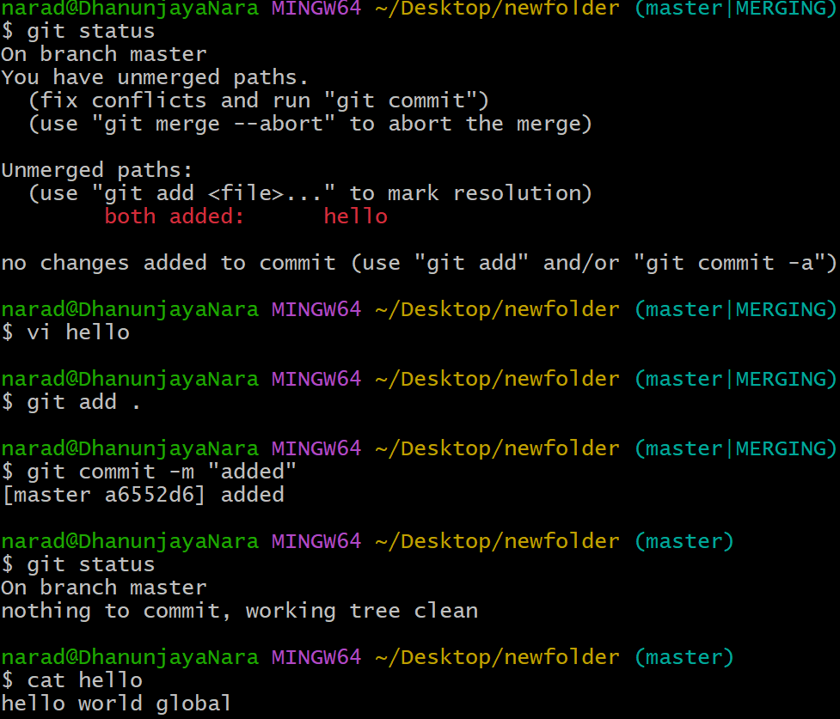
I added that tracking area and edited that file manually and added and committed that.

2.Recover Deleted Branch
Delete a local branch and then recover it using the reflog.
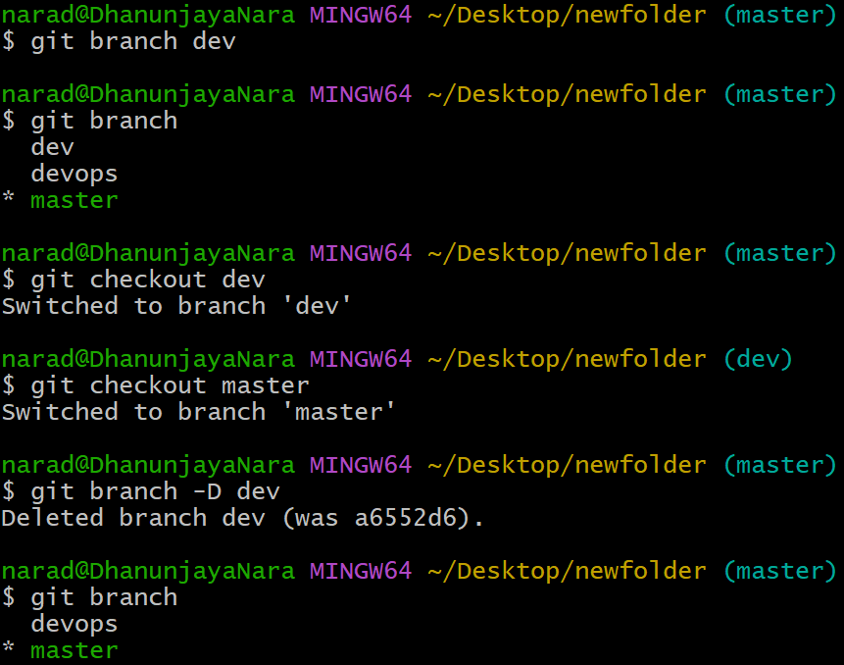
Here first I created a branch named dev and deleted after going into master branch with
git branch -D dev.
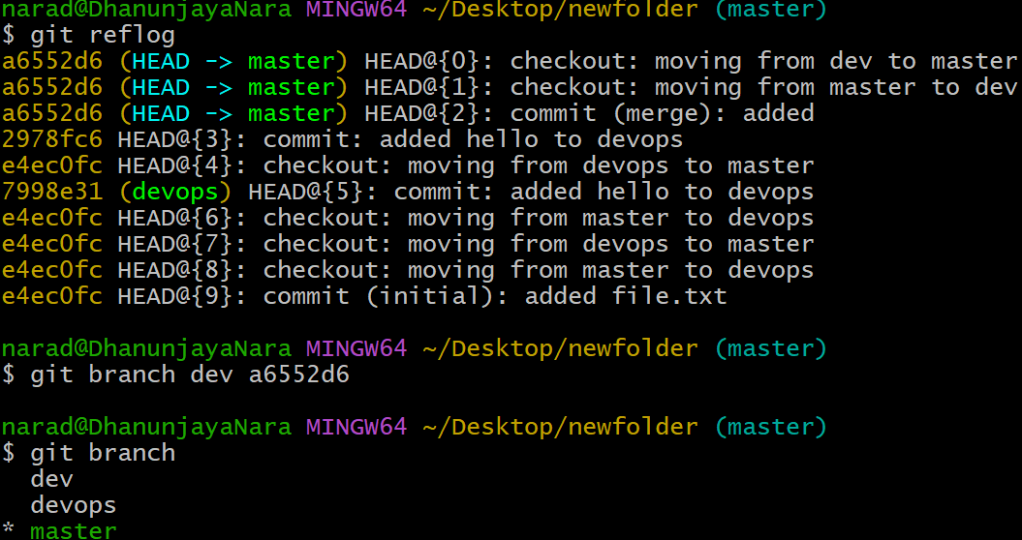
We can recover the deleted branch using reflog.
We can commit id of the deleted branch dev.
We can retrive that with [git branch dev a6552d6].
And check the branch using git branch.

3.Undo Wrong Push
Push a wrong commit to GITHUB, then undo it without losing history.
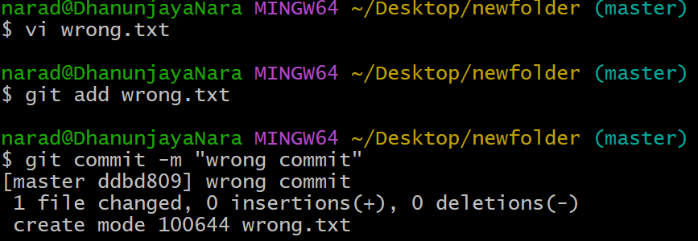
Here first I created a file wrong.txt and moved that to tracking area and also committed that.
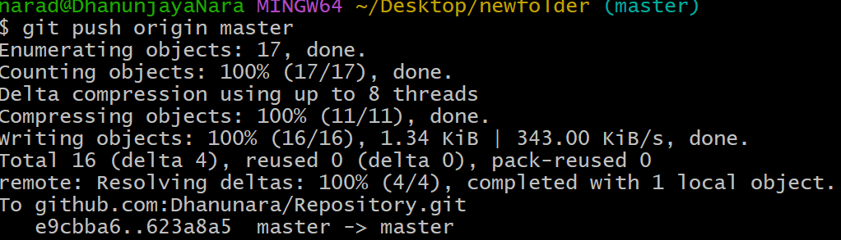
And pushed that to remote repo using [git push origin master].
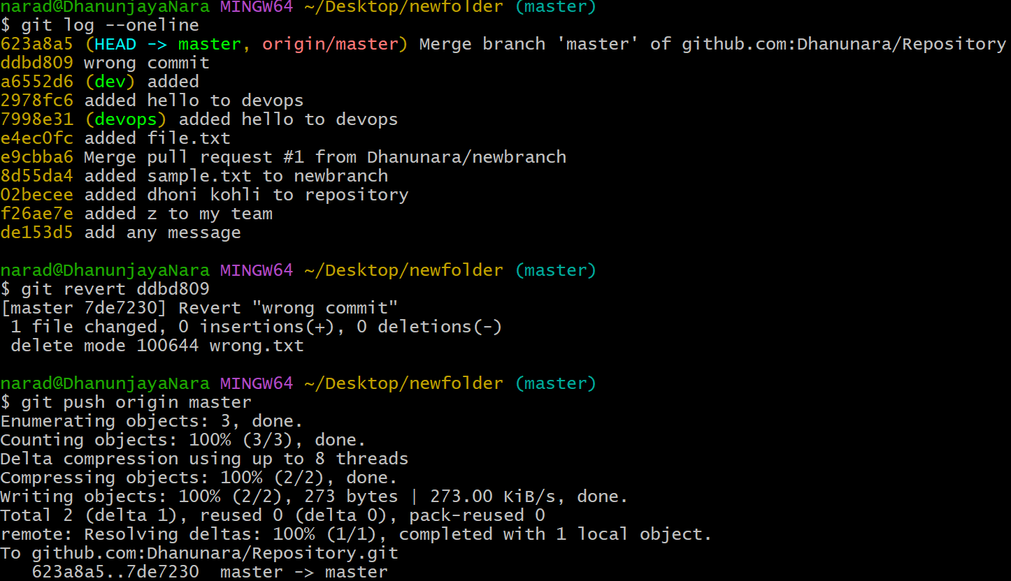
We can get the wrong commit id by [git log --oneline].
And we should copy the commit ID of wrong commit .
We can revert the wrong commit by using [git revert commit ID ].
And it will open vi just exit and enter.
Push that undo commit using git push origin master.

4.Amend a commit
Make a commit ,then add a missing file to it using git commit --amend.
First we need to create a file1 using touch command and edit the file using vi and add that file to tracking area using git add, and also commit that particular file using git commit -m .
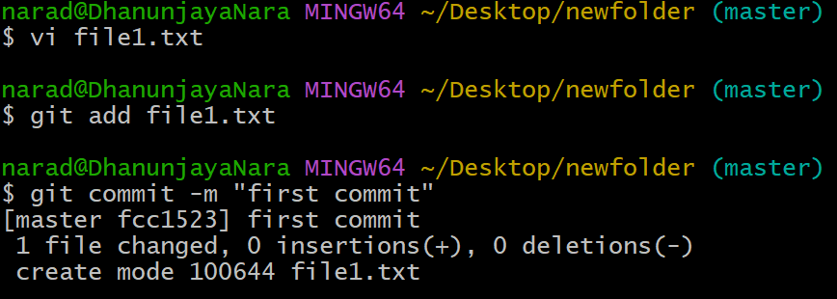
And again I created one more file missing.txt and edited that file using vi and also added that to tracking area with git add .
git commit --amend which will updates the last commit to include missing file , which will open vi showing the same commit message.
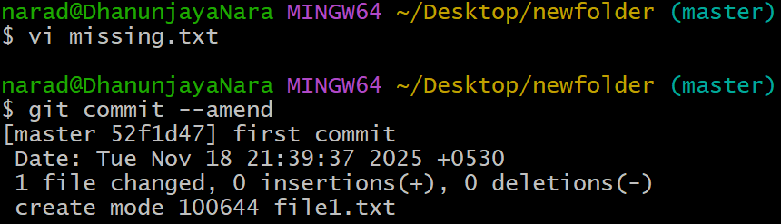
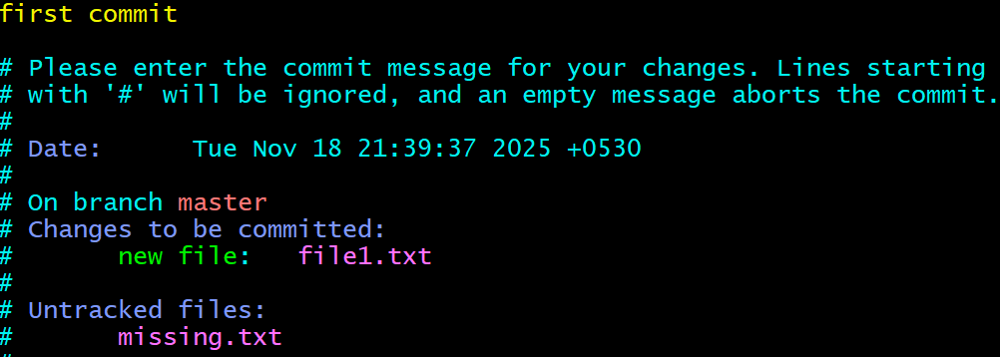

5.Cherry-pick a Commit.
Take a specific commit from one branch and apply it to another branch.
Here we should use commit ID of particular file which we want to add to another branch with the help of git log.
And after going into master branch execute git cherry-pick and paste that commit ID.
Now after doing ls we can see the that even in another branch as well.
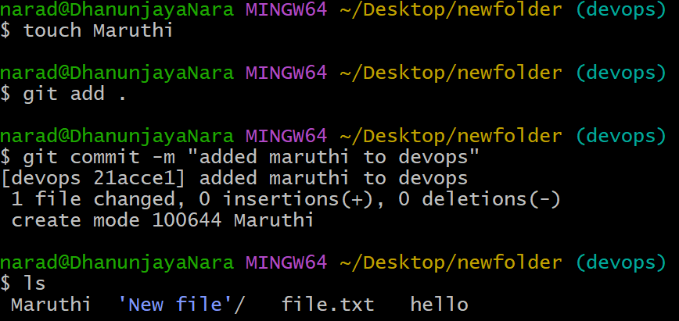
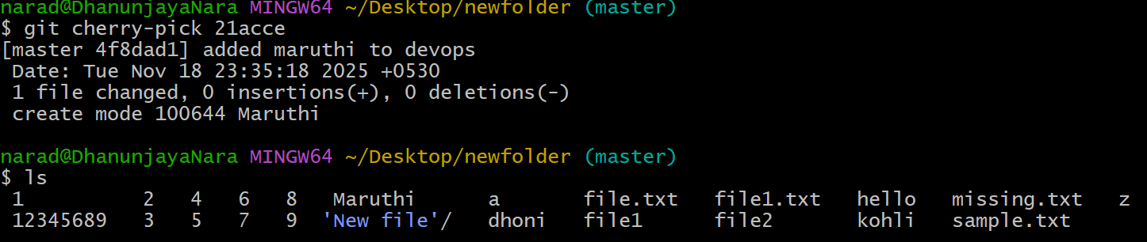

6.Interactive Rebase.
Reorder and squash multiple commits into a single clean commit.
Three files are created and edited using vi command.
And added those files to tracking area by using git add and committed them using git commit -m .
And when we execute git rebase -I HEAD~n it will opens a screen in vi and can edit there.
We can change the order of the commits.
Pick = keep commit
Squash = merge into the previous commit.
After editing in vi check with git log --oneline. We can see the one single commit.
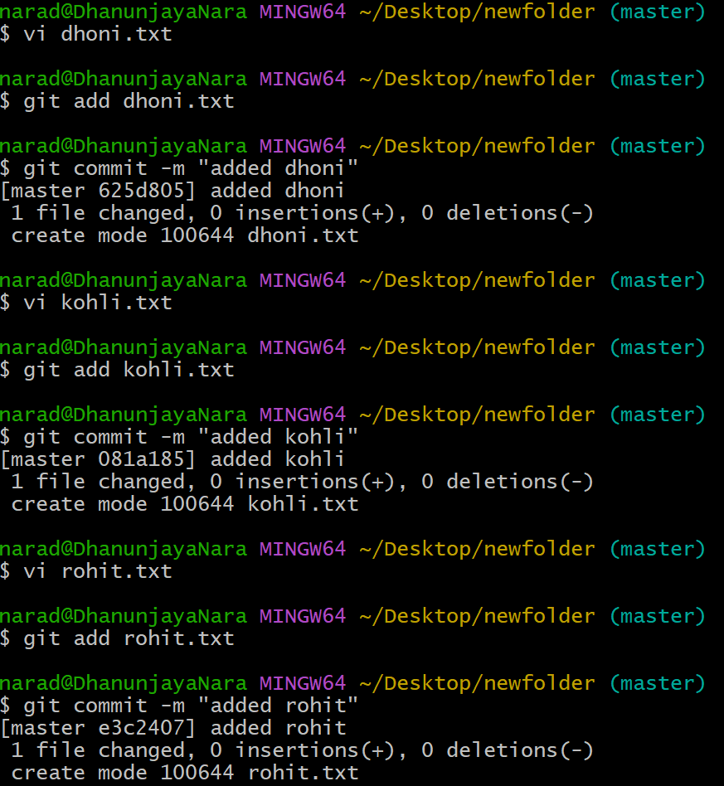

7.Tagging & Release.
Create a version tag (v1.0), push it to GITHUB, then delete and restore it.
Commit should be created first so that we can tag that and add that to tracking area and also commit that message as well.
Create a tag using git tag and to check we can use git tag.
And push the tag to github using git push origin master.
And to delete the tag locally we can use git tag -d v1.0
And to delete the tag from github git push origin --delete v1.0
And to restore again we need to tag again and push that restored tag to github again.
And push the restored tag to github using git push origin v1.0
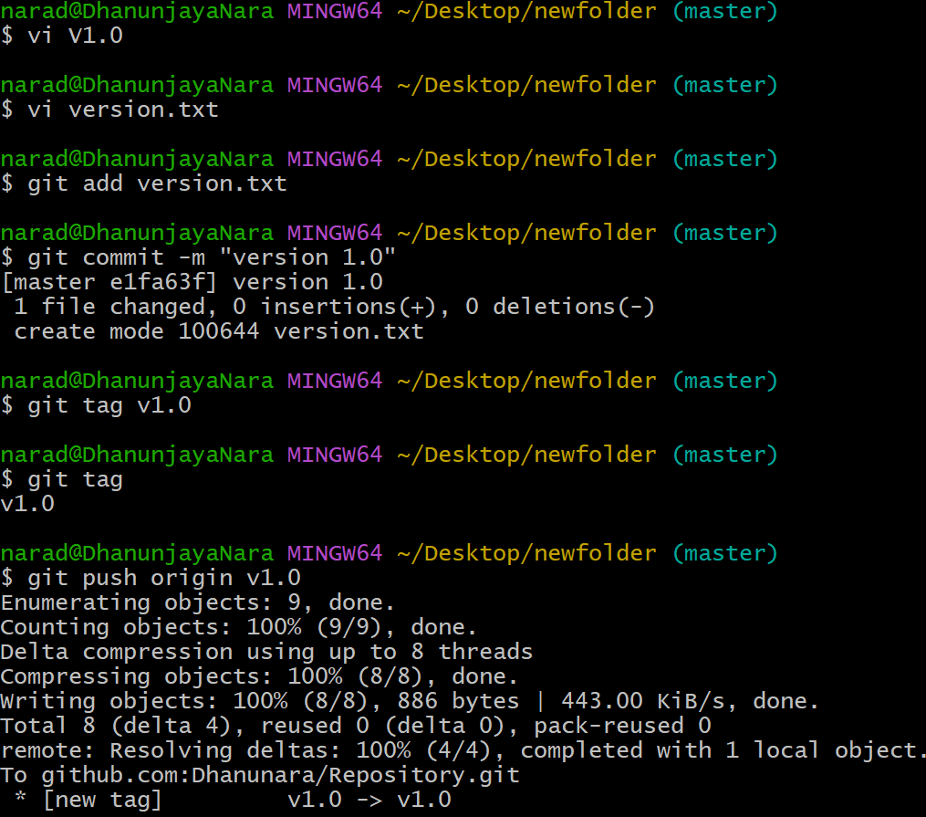

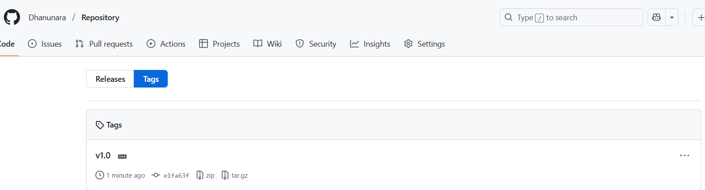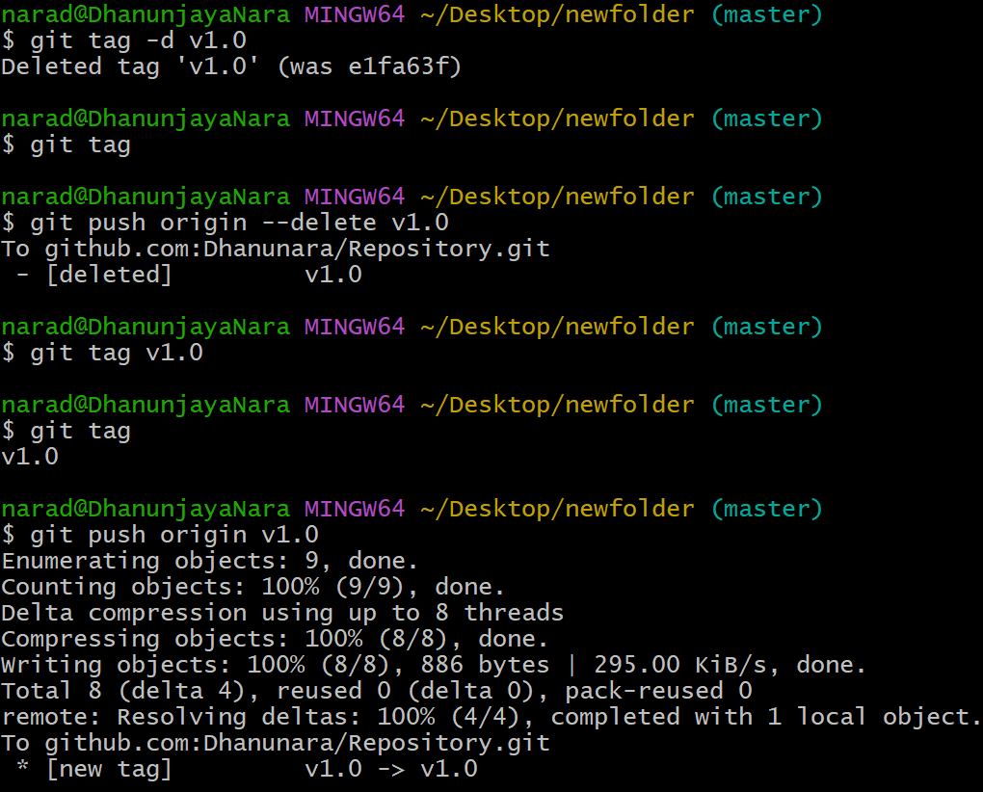

8.Clone With Sparse Checkout
Clone only a subdirectory of a repo using sparse checkout
First a new folder need to be created and should do cd folder. And initialise the git
git remote add origin and paste repo url and check it with remote -v
Now enable sparse checkout with git sparse-checkout init --cone
And we should choose the subfolder to clone
git sparse-checkout set subfolder and git pull origin master.
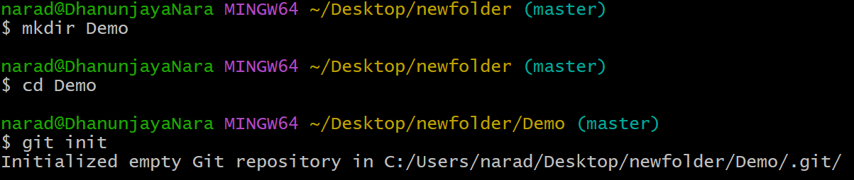
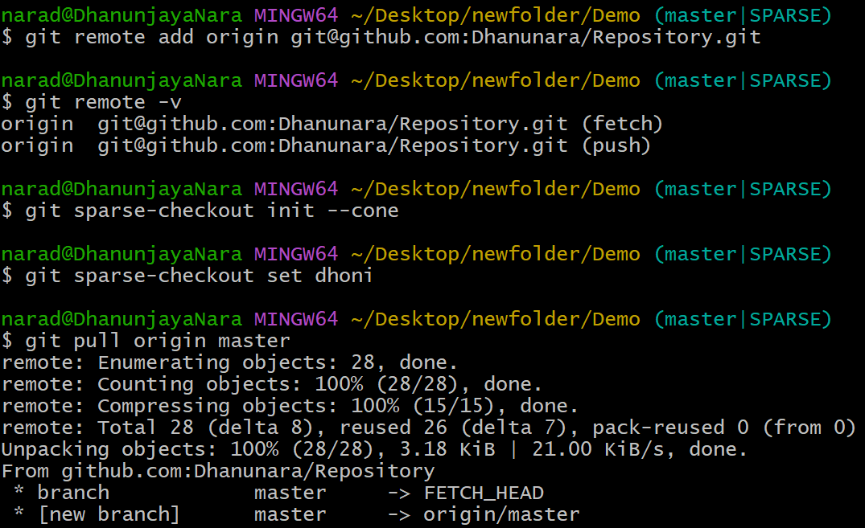
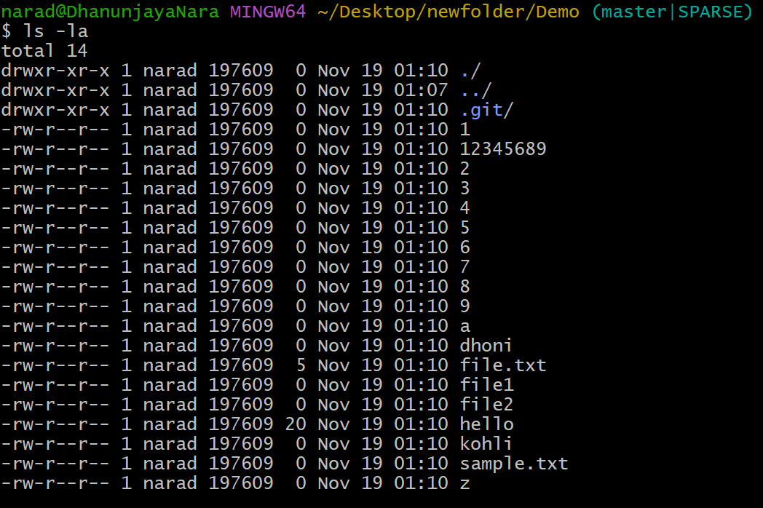
9.Reset vs Revert Challenge
Demonstrate the difference between git reset --hard and git revert in a repo.
First we should create a folder and should move inside that folder and start git using git init.
Then create a file and add three commit messages to that file and add that file to tracking area by git status and also commit three messages with git commit -m .
Now check the commit history with git log --oneline . we can see all the commits and IDs as well.
Now using git reset --hard commit id of first line and you can see only that first line other two and three will be deleted.
Again recreate that deleted commits so we can revert them.
Use git revert HEAD a new commit is created that removes third line and we can see only first and second lines.
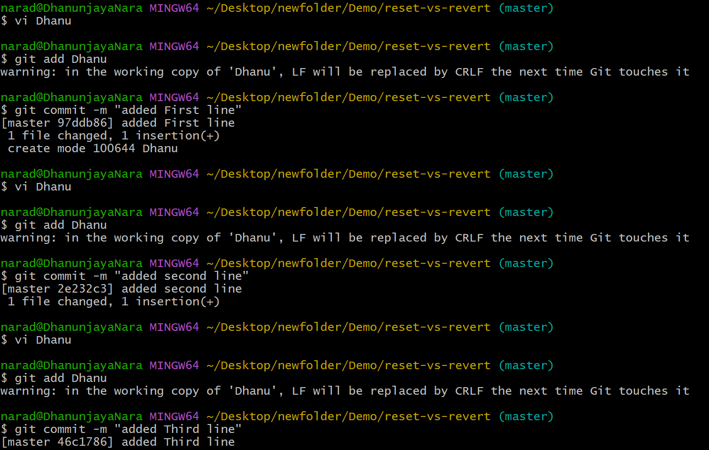
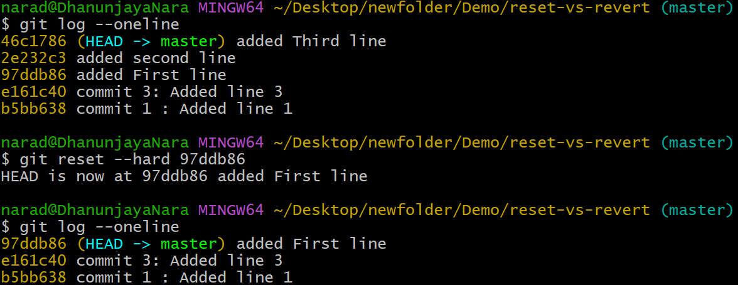
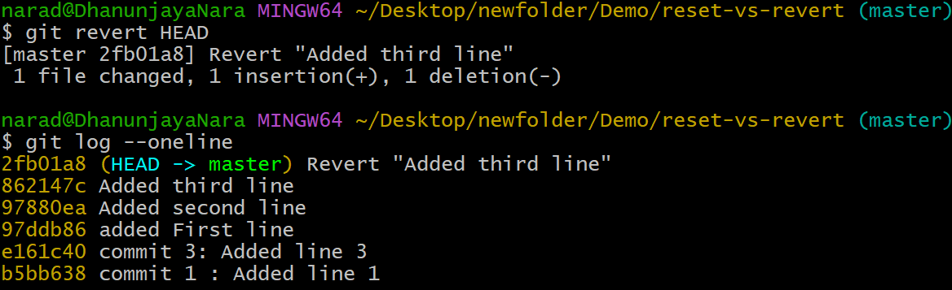

10.Detached HEAD Challenge
Checkout a specific commit (detached HEAD state) and create a new branch from it.
First create a new folder and move into that folder and start git with git init.
We need to create a file and three commits to checkout one later.
And check the commit history using git log --oneline.
And now take the commit ID of a commit and do git checkout ID .
Now git shows us that we are in a ‘detached HEAD’ state.
To check the use git branch it will show in detached HEAD .
To create a new branch from detached HEAD commit use git checkout -b branchname.
Now to check the branch use git branch. 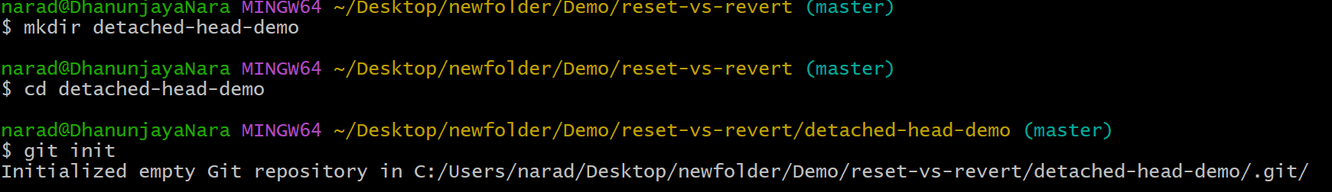
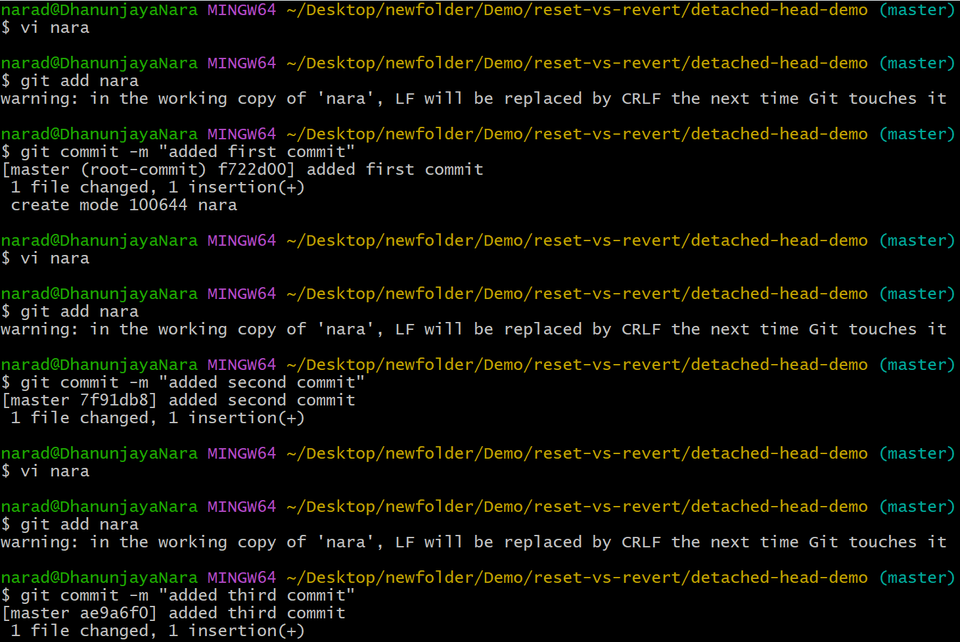
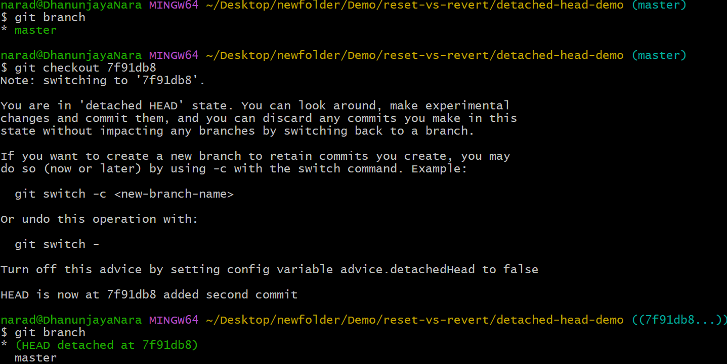
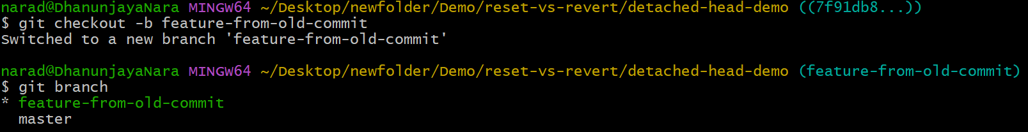

12.Squash Merge vs Rebase Merge
Show the difference between squash merge and rebase merge with evidence.
First we need to create a folder and should move to that folder and start git with git init.
First we should create base commits on master and should check those with git log –oneline.
And create one more branch and also add commits and add those to tracking area and commit them also. And check those commits using git log --oneline .
And to create a squash merge first checkout from the new branch and checkout to master and enter git merge --squash newbranch.
And after that check with git log --onleine.
Now to rebase first enter into newbranch and enter git rebase master.and we can check that using git log --oneline.
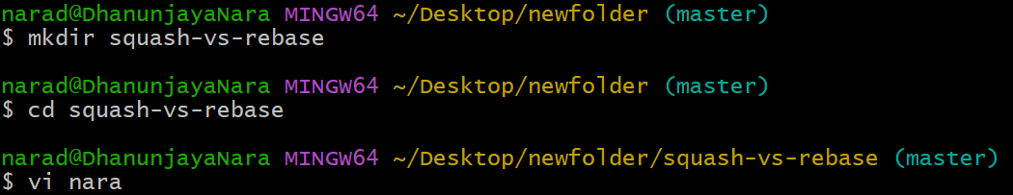
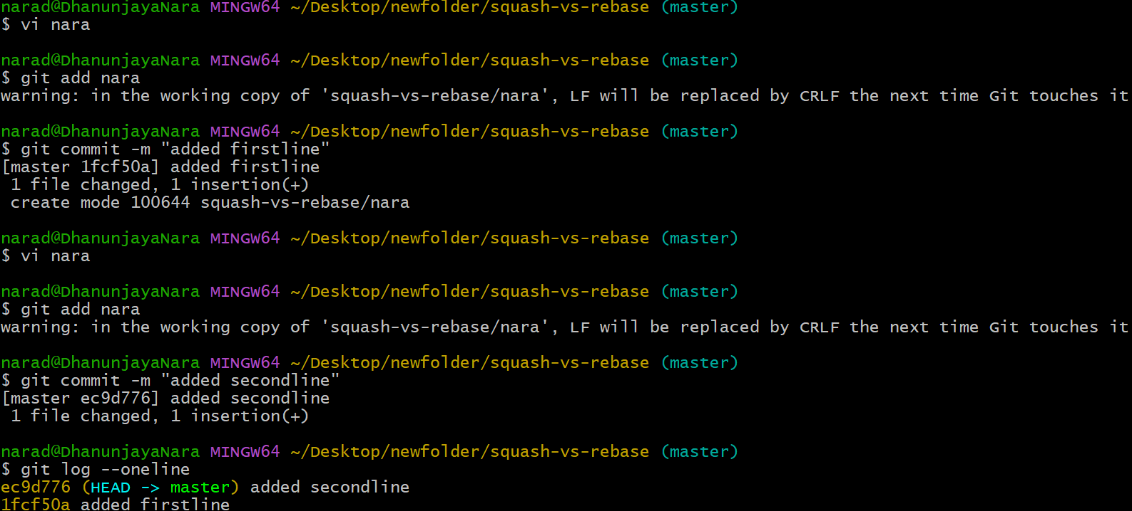
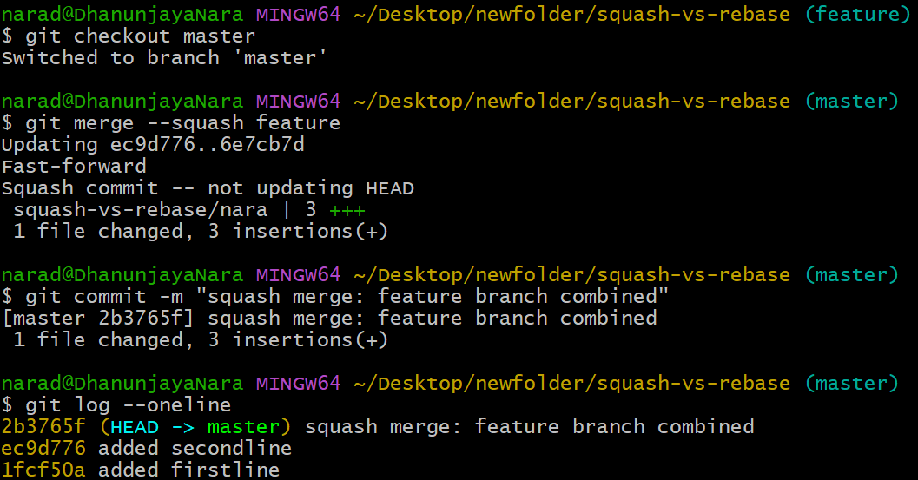

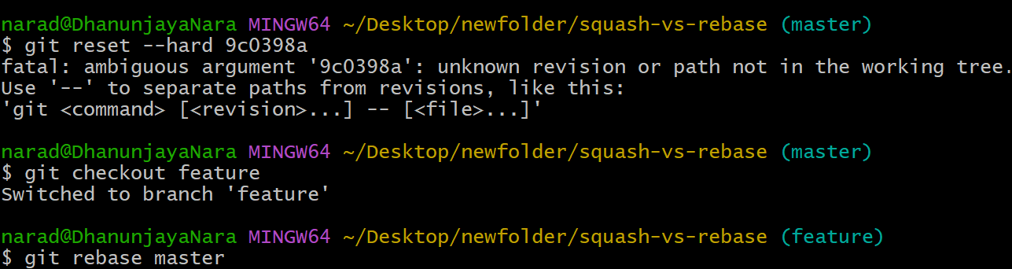

14.Recover Lost Commit.
Commit something , reset hard , and then recover it using git reflog.
First create a file and add commits to that and add that to tracking area using git add and and commit them using git commit -m .
Then check those commits using git log --oneline.
And now if we want to remove the commit git reset --hard commit ID .
And if we do git log --oneline we cannot get that commit.
Now using git reflog we will get all movements of HEAD even those deleted by reset.
So we can recover the lost commit using git reset commit ID.
And do git log --oneline to check the recovered commit.
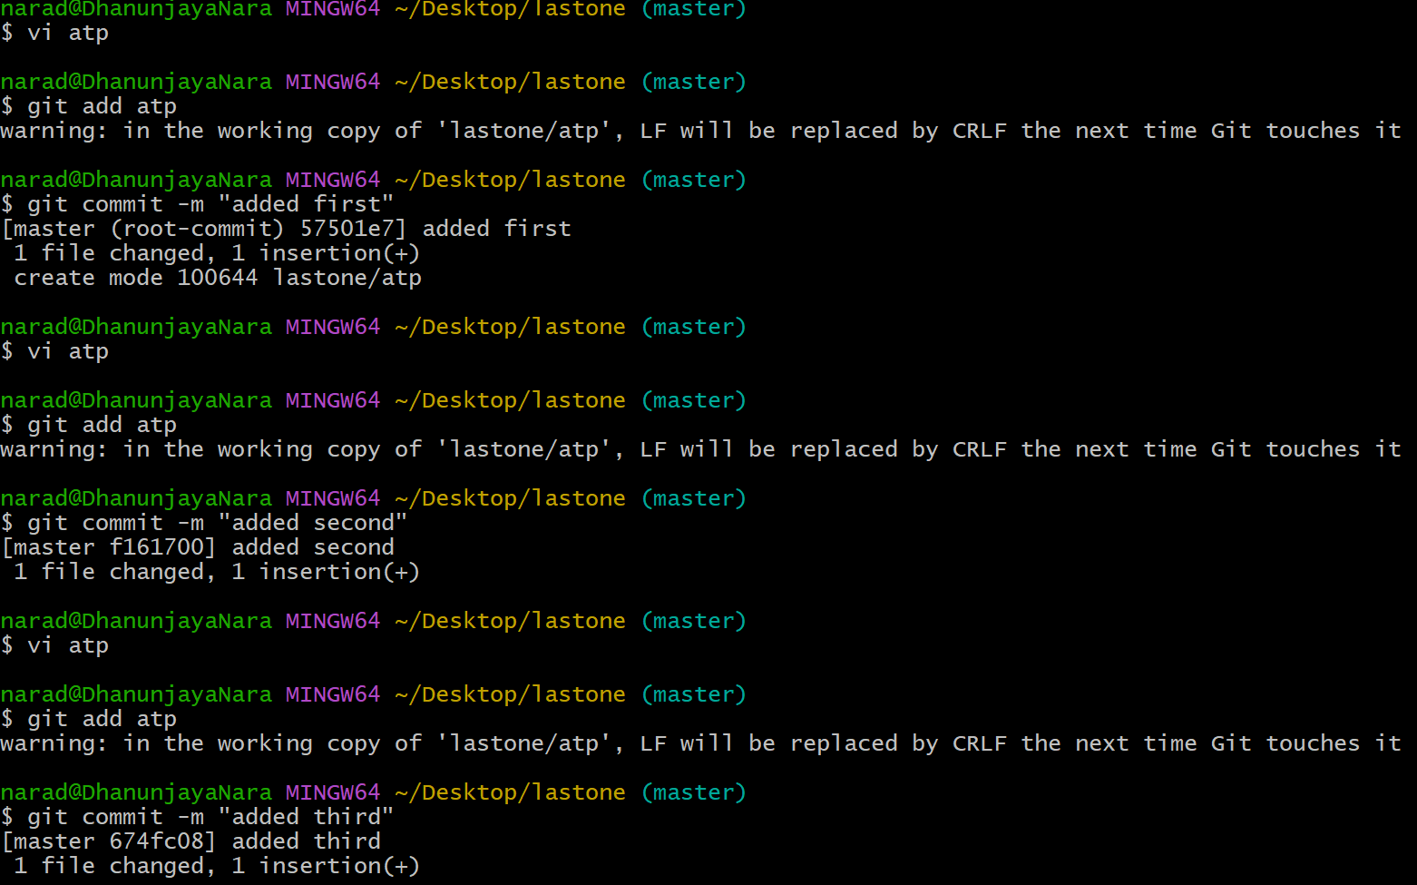
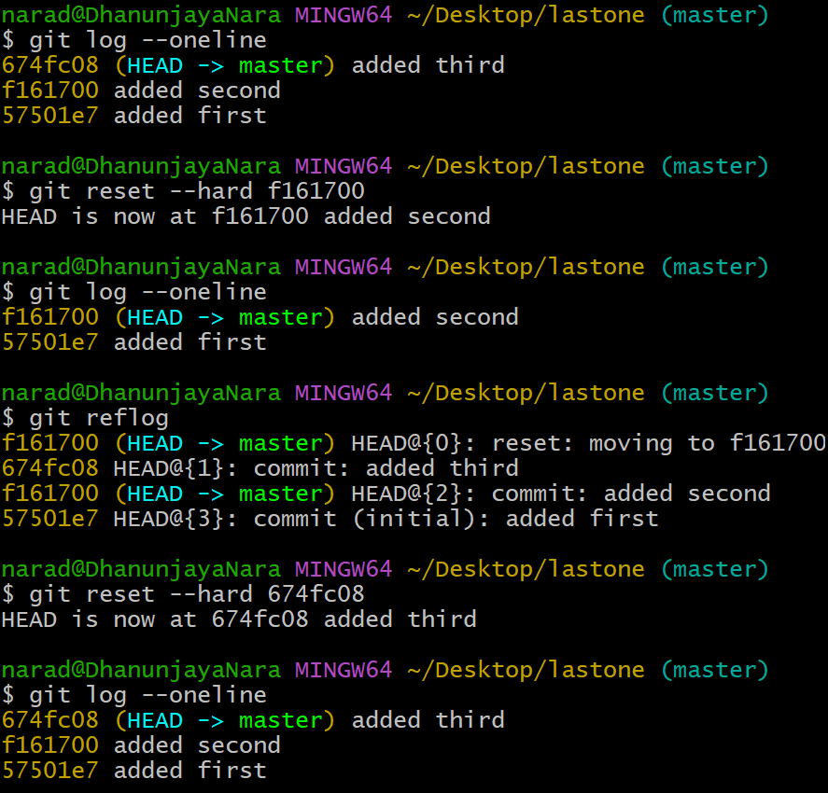

13.Fork & Pull Request Workflow.
Fork a repo,make a change and submit a pull request to the original repo.
We can fork the another repository using the url.
After fork we can make changes in that as well.

